

**IFSO Endorsement of Webinars in the field of Obesity and Metabolic Disorders**

Endorsement requests must be sent to IFSO Secretariat (info@ifso.com) along with the scientific program of the Webinar. IFSO relevant Committee will carefully review the concepts and objectives of the Webinar as well as the faculty, the structure and content of the Webinar, in deciding about the endorsement.

“Endorsement” does not in any way offer credentialing of grant approval to the participant regarding future skills and outcomes.

IFSO doesn't endorse events organized by a "parallel" society of a country where there is an "official" national society in IFSO.

* **Requirements**

􀀀 The complete application has to be received at latest 2 weeks prior to the event. Applications received less than 2 weeks before will be automatically rejected.

􀀀 The Webinar must be directed or coordinated by an IFSO member

􀀀 Endorsed Webinars should possibly offer CME credits (not mandatory)

􀀀 The Director/Organizer must ensure that disclosure of conflict of interest are enforced

􀀀 The Director/Organizer must show in his/her presentation(s) the Case Mix Disclosure slide (see attached) and recommend its use to all the speakers.

􀀀 Reduced registration fees (if any) must be granted to IFSO Members

􀀀 A detailed PDF file of the scientific program with titles of presentations and faculty must be provided at the time of application.

* **Fees**

INDIVIDUALS: $100,00

CORPORATE: $500,00

* **Benefits:**

Endorsed Webinars will be:

􀀀 listed on IFSO’s Website on the “Endorsed meetings” page with the link for the registration

􀀀 included on IFSO’s E-newsletter

􀀀 mailed once to IFSO Members

􀀀 advertised once on IFSO Facebook page

􀀀 the Director may include IFSO’s Endorsement statement and IFSO Logo on promotional materials among the endorsing institutions, exclusively with the following text: “***Endorsed by***” before the logo of IFSO.

* **People’s first language:**
* Use patients with obesity, people with obesity, woman/man/child with obesity
* Use severe obesity (or reference BMI range or Class), never morbid obesity or super-obesity or extreme-obesity
* Eliminate "success/failure" "recidivism" "non-compliant" "gold-standard" "last-resort" sort of language
* Avoid weight-loss surgery, instead use bariatric-metabolic surgery
* Imagery (no headless, stereotypical/stigma = takeaway boxes, fast food, ill-fitting clothes, etc.)

|  |  |
| --- | --- |
| **Old and not accepted per Journal Policy** | **New replacement nomenclature** |
| **Mini Gastric Bypass (MGB)** | **One Anastomosis Gastric Bypass (OAGB)** |
| **Morbid Obesity** | **Severe Obesity** |
| **Obese/Diabetics** | **Patient or individual with obesity/ diabetes** |
| **Subject/s** | **Patient/s or individual/s** |
| **Weight loss surgery** | **Metabolic Bariatric Surgery (MBS)** |
| **Super or super-super obesity** | **Please use Body Mass Index reference BMI>50 or BMI>60 to refer to this patient population respectively** |
| **Gold standard** | **Avoid using this term please** |
| **Revision procedure** | **‘Revision or modification’ for any procedure that does not encompass conversion to a new procedure with a new mechanism of action or reversal of the anatomy.** Revision or modification encompasses correction or an enhancement of the same procedure (revision of a gastric pouch, distalization of gastric bypass) |
| **Conversion procedure** | **‘Conversion’ entails converting one procedure to another with a different mechanism of action.** Revision is not accepted as a substitution anymore |
| **Reversal procedure** | **Term can still be used to describe reversing a procedure to the normal standard anatomy** |
| **Insufficient or inadequate weight loss** | **‘Suboptimal clinical response’ encompasses maximum total weight loss outcome (TWL%) <20%, while also covering no improvement or worsening of any obesity complication that was present preoperatively** |
| **Weight loss failure** | **Failure is not an acceptable term anymore. Use suboptimal clinical response if fits these criteria** |
| **Adequate weight loss** | **Optimal clinical response which follows the criteria of TWL% >20% and/or improvement of obesity complication/s** |
| **Success** | **This term is not acceptable anymore. Please use Optimal clinical response for primary procedures or optimal clinical response for other revision or conversion procedures** |
| **Restrictive or Malabsorptive procedures** | **These terms are not acceptable to use. Please describe procedures per their anatomic features, bypass, diversion, etc …** |
| **Malabsorption/Hypoabsorption** | Both are accepted, but it is **essential to report: Micronutrient for minerals and elements versus Macronutrient for protein/fact or carbohydrates** |
| **Weight regain/ recurrence** | **Recurrent weight gain** |
| **Bariatric Surgery** | **Metabolic Bariatric Surgery (MBS)** |
| OLD DEFINITION:  **Anti Obesity Medications** | NEW DEFINITION:  **Obesity Management Medications (OMMs)** |

* BMI 30 <35kg/m2 Obesity I
* BMI 35 <40kg/m2 Obesity II
* BMI 40 <50kg/m2 Obesity III
* BMI 50 <60kg/m2 Obesity IV instead of „Super Obesity“
* BMI 60 <70kg/m2 Obesity V instead of „Super-Super Obesity“

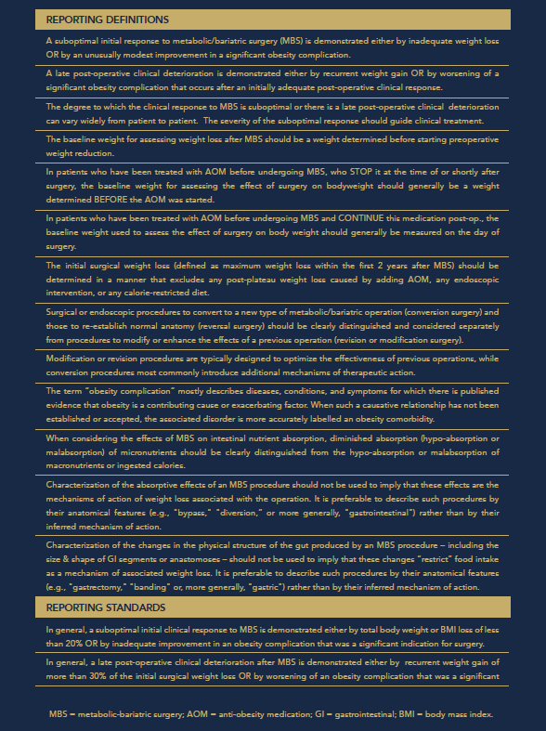

* **Diversity statement:**

IFSO encourages diversity such as gender, age and geographical representation. Therefore, we encourage to take into account diversity in selecting the faculty of your educational events.

If you think your Webinar fulfils the above-mentioned requirements, please send your request to info@ifso.com by filling the following form together with a PDF file of the scientific program.

After the approval of the Communication Committee you will receive further instructions about the payment of the endorsement fee.

**IFSO WEBINAR ENDORSEMENT APPLICATION FORM**

EVENT DIRECTOR*:

INSTITUTION/SOCIETY (IF ANY):

TITLE OF THE EVENT*:

DATE/S*:

TYPE OF EVENT:

WEBSITE OF THE EVENT*:

ADDRESS*:

CITY*: STATE: ZIP:

PHONE:

E-MAIL*:

WILL CME CREDITS BE OFFERED*? ⬜YES ⬜NO

IF YES, HOW MANY?*

IF NO, WHY?*

WHICH INSTITUTION PROVIDES THE CME CREDITS:

WILL THE EVENT BE DISCUSSING/DEMONSTRATING EXPERIMENTAL PROCEDURES, TECHNOLOGY AND/OR THERAPIES: ⬜YES ⬜NO

IF YES: HAVE THE RIGHT APPROVALS AND CONSENTING BEEN SECURED: ⬜YES ⬜NO

ARE DISCLOURES OF CONFLICT OF INTEREST ENFORCED*? ⬜YES ⬜NO

DISCOUNT FOR IFSO MEMBERS (min 10%)*:

□ I have read and understood the IFSO Position Statement on Live Surgeries and informed the operator(s) accordingly. I declare that the answer to all points is in the affirmative for both the operator(s) and the organizer(s).*

**\*Mandatory field**

**BILLING INFORMATION\***

NAME (PERSON/COMPANY/INSTITUTION):

ADDRESS:

EMAIL:

DATE:

SIGNATURE EVENT ORGANIZER: