IFSO Endorsement Application Form

Requirements
Endorsement requests must be sent to IFSO Secretariat (info@ifso.com) together with the scientific program of the Event in English. IFSO relevant Committee will carefully review the concepts and objectives of the course as well as the faculty, the structure and content of the course, in deciding about the endorsement.
“Endorsement” does not in any way offer credentialing of grant approval to the participant regarding future skills and outcomes.

- Single Endorsement

􀀀 Single Endorsement is only available for one event.
􀀀 The complete application has to be received at latest 3 weeks prior to the event. Applications received less than 3 weeks before will be automatically rejected.
􀀀 The event must be directed or coordinated by an IFSO member, or have as its primary faculty, at least one IFSO member
􀀀 Endorsed events should offer CME credits (if not, an explanation must be provided)
􀀀 The Director must ensure that disclosure of conflict of interest are enforced
􀀀 The Director must show in his presentation(s) the Case Mix Disclosure slide (see attached) and recommend its use to all the speakers.
􀀀 Reduced registration fees must be granted to IFSO Members

The fee for single endorsement is $400,00

- Multiple Endorsement

􀀀 Multiple endorsement is meant for two or more events held per year at the same institution
􀀀 The complete application has to be received at latest 3 weeks prior to the event. Applications received less than 3 weeks before will be automatically rejected.
􀀀 The events must be directed or coordinated by an IFSO member, or have as
its primary faculty, at least one IFSO member
􀀀 The agendas and faculty lists of all events that will be held during the year must be submitted at the moment of application for annual review and approval
􀀀 The institution/centre must be equipped with adequate facilities
􀀀 Endorsed events should offer CME credits (if not, an explanation must be provided).
􀀀 The Director must ensure that disclosure of conflict of interest are enforced
􀀀 The Director must show in his presentation(s) the Case Mix Disclosure slide (see attached) and recommend its use to all the speakers.
􀀀 Reduced registration fees must be granted to IFSO Members

The fee for multiple endorsement is $1.200,00/year

Benefits:
Endorsed events will be:
􀀀 listed on IFSO’s Website on the “Endorsed meetings” page, with a link to the congress website
􀀀 included on IFSO’s E-newsletter
􀀀 emailed twice to IFSO Members
􀀀 advertised once on IFSO Facebook and Twitter page
􀀀 the IFSO “Endorsed by” Logo should be included on the promotional material

People’s first language/ IFSO accepted nomenclature:

- Eliminate "success/failure" "recidivism" "non-compliant" "gold-standard" "last-resort" sort of language
- Imagery (no headless, stereotypical/stigma = takeaway boxes, fast food, ill-fitting clothes, etc.)

Old and not accepted per Journal Policy | New replacement nomenclature
Morbid obesity | Severe obesity
Obese/Diabetics | Patient or individual with obesity/ diabetes
Subject/s | Patient/s or individual/s
Weight loss surgery | Metabolic Bariatric Surgery (MBS)
Super or super-super obesity | Please use Body Mass Index reference BMI>50 or BMI>60 to refer to this patient population respectively
Gold standard | Avoid using this term please
Revision procedure | ‘Revision or modification’ for any procedure that does not encompass conversion to a new procedure with a new mechanism of action or reversal of the anatomy. Revision or modification encompasses correction or an enhancement of the same procedure (revision of a gastric pouch, distalization of gastric bypass)
Conversion procedure | ‘Conversion’ entails converting one procedure to another with a different mechanism of action. Revision is not accepted as a substitution anymore
Reversal procedure | Term can still be used to describe reversing a procedure to the normal standard anatomy
Insufficient or inadequate weight loss | ‘Suboptimal clinical response’ encompasses maximum total weight loss outcome (TWL%) <20%, while also covering no improvement or worsening of any obesity complication that was present preoperatively
Weight loss failure | Failure is not an acceptable term anymore. Use suboptimal clinical response if fits these criteria
Adequate weight loss | Optimal clinical response which follows the criteria of TWL% >20% and/or improvement of obesity complication/s
Success | This term is not acceptable anymore. Please use Optimal clinical response for primary procedures or optimal clinical response for other revision or conversion procedures
Restrictive or Malabsorptive procedures | These terms are not acceptable to use. Please describe procedures per their anatomic features, bypass, diversion, etc …
Malabsorption/Hypoabsorption | Both are accepted, but it is essential to report: Micronutrient for minerals and elements versus Macronutrient for protein/fact or carbohydrates
Weight regain/ recurrence | Recurrent weight gain

- BMI 30 <35kg/m2 Obesity I
- BMI 35 <40kg/m2 Obesity II
- BMI 40 <50kg/m2 Obesity III
- BMI 50 <60kg/m2 Obesity IV instead of „Super Obesity“
- BMI 60 <70kg/m2 Obesity V instead of „Super-Super Obesity“

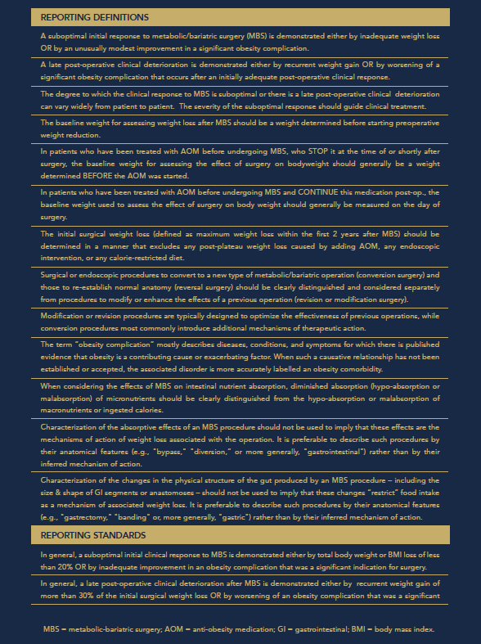

Diversity statement:
IFSO encourages diversity such as gender, age and geographical representation. Therefore, we encourage to take into account diversity in selecting the faculty of your educational events.

Upcoming IFSO World Congress
The organizer of the endorsed meeting commits to:
1) Post on the meeting's website the digital flyer and the link to the website of the upcoming IFSO World Congress.
2) Display posters or flyers of the IFSO World Congress at the endorsed meeting's venue.

If you think your event fulfils the above mentioned requirements, please send your request to info@ifso.com by filling the following form together with a PDF file of the scientific program.
After the approval of the relevant Committee, the Applicant will receive further instructions about the payment of the endorsement fee.

Application form

EVENT DIRECTOR*: ______________________________________________________________________________
INSTITUTION/SOCIETY (IF ANY): _________________________________________________________________
TITLE OF THE EVENT*: ___________________________________________________________________________
DATE/S*: ________________________________________________________________________________________
TYPE OF EVENT: _________________________________Website of the event*: _____________________________
ADDRESS*: ______________________________________________________________________________________
CITY*: _______________________________ STATE: _________________________ ZIP: ______________________
PHONE: ______________________________________ FAX: _____________________________________________
E-MAIL*: ________________________________________________________________________________________
WILL CME CREDITS BE OFFERED*? __ YES __ NO IF YES, HOW MANY?*______________________________
IF NO, WHY?*____________________________________________________________________________________
WHICH INSTITUTION PROVIDES THE CME CREDITS:_______________________________________________ ________________________________________________________________________________________________
ARE DISCLOURES OF CONFLICT OF INTEREST ENFORCED*? ____YES _____NO
DISCOUNT FOR IFSO MEMBERS (min 10%)*_______________________________________________________
□ I have read and understood the IFSO Position Statement on Live Surgeries and informed the operator(s) accordingly. I declare that the answer to all points is in the affirmative for both the operator(s) and the organizer(s).*

*Mandatory field

BILLING INFORMATION*
Name (person/company/institution): ________________________________________________________________
Address: ______________________________________________________________________________________
Email:________________________________________________________________________________________
Date Signature Event Director
_____________________ _________________________

